June 2015 Newsletter



Commodores Report
Now when you go to the club you will see that we have a 50inch LED screen. I would encourage any member to show their club related photos and videos of interest (via a USB input). I must point out that this will not be for TV broadcasts: we will not have a TV Licence.
On the subject of upgrading technology at the club, we have purchased a landline telephone service with broadband and are waiting for this to be installed. Wi-Fi will follow if there is a responsible demand for it. I would not want to see it used for computer gaming or irresponsible use; especially at the expense of interfering with the social atmosphere of the club.
Your committee made the decision, following Lesley’s (Vice Commodore) tireless research, that this year’s formal dinner/dance in November (Saturday 7th) will be at a local hotel to keep the cost to an acceptable level. The hotel chosen is the Warren Lodge, Shepperton Village Square and a formal reservation has been made. It meets all our requirements and we estimate will be between £40 and £50 pp for 40+ guests; including a 3-course meal and entertainment. Hotel accommodation is available at discounted cost (only if booked direct with the hotel) and there are rooms with disabled access. All we need now is your support.
The club’s participation in the 75th Anniversary crossing to Dunkirk was disappointing when, in the end, only two club members made the channel crossing. Some who had intended to go had their boats out of commission as the date approached, and also at the last minute, and I know how frustrating and disappointing that must have been. Unfortunately, we will have to wait 5 more years for the next opportunity. See Colin Barnard’s article below.
On 20th June we had our Mid-Summer Ball and what a great success it was. The DJ had us dancing all evening: I rate it a success as the dance floor was full right to the last dance at 11.30. Those of you not there missed Gill Watson’s and Mandy Hoyle’s excellent 3-course meal. See Jessie’s article.
Like many clubs we are in difficulty with recruitment; we are losing more than gaining: 107 members in 2014 compared with 100 so far this year: boat ownership is also falling. Phil (Membership) is working hard to find ways to improve recruitment; he is right when he says that every member should take responsibility to recruit a new member. If the current attrition continues, in 2 or 3 years the club could become unsustainable. To publicise the club we have club sponsored Cruise Planners with a number of marinas and as soon as we have a landline phone number I can publish the WMC pamphlet and business card (if you wish to see them please let me know).
Our Booking Secretary, Christine, is doing a great job managing the hire of the club house. Not only does she deal with the hirers to see they comply with the new Terms and Conditions, she also has to make sure that booked events run smoothly, that the bar is staffed and at the end all is in order: very hard and time consuming for the club event team when some bookings keep the bar busy for very long periods. Thanks to Christine and her gang of helpers; but it would be good if Christine could have more help with staffing the events. Remember the bookings are a very valuable input to our accounts and help to keep the membership fees and bar prices down.
The next event is the up-river cruise, starting on 4th July at Boveney lock. Rob (Rear Commodore Non-Tidal) has booked the lock mooring for a barbecue and overnight stay. He will also be arranging rendezvous points to Abingdon and return. The cruise will arrive at Hurley in time for those of us in the TSCC – so no excuses! See the flyer at the club and please do put your name on the list; after all we are a boat club. Even if you don’t have a boat you can still put your name on the list to meet up at a rendezvous location.
We are now well into the boating season. Let’s hope for good weather and happy boating – enjoy.
Jim Pothecary.

The Dunkirk Crossing
On Monday 18th May, the weather was good and forecast fair, when we set sail to join up with the Dunkirk support fleet in Ramsgate on the 75th anniversary of the evacuation of troops from France, assisted by the small ships from all over England, particularly the Thames area. We had expected when this event was arranged, to be in company of 12 craft from Weybridge Mariners Club. Due to all manner of reasons we were reduced to just 2, “Serenade” and “Harveys Joy”, To carry the flag for the club.
We joined Harvey’s Joy at Teddington and timed our run down to Limehouse Basin to pass through Richmond as the barrier was lifted. The trip was uneventful arriving in Limehouse spot on time to pass under the road bridge; the arch on Serenade lowered. The wind was quite gusty all evening.
Tuesday 19th the weather was bright with a light breeze, and tide set for a good long run to Ramsgate, expecting to arrive at dusk. From Gravesend we followed the main channel from west to East Blyth. We had travelled more slowly than originally planned resulting in approaching the Gore Channel near to the bottom of the tide. We then took a northerly course to skirt around Margate sands to the North Foreland arriving in Ramsgate at 23.15 Hrs having travelled about 11hrs.
Wednesday 20th A day of great activity with a memorial service in the marquee on the harbour wall, visiting the little ships, watching the marching troops, bands and enjoying the general ambience and hubbub of Ramsgate, at its busiest probably since the war. Harvey’s Joy reported that they had trouble with the alternator and was seeking repair or replacement.
Thursday 21st Unfortunately Harvey’s Joy was not able to fix the problem in time to sail to Dunkirk. After the epic sight of the little ships assembling outside the harbour for the crossing, we set out, minus Harvey and Joy on the crossing to France. The wind was light and the sea slight. The crossing took 3hr 30min, our usual time and we arrived in Gravelines, our favourite port, which was bathed in sunshine. A phone call confirmed that Harvey and Joy would not be joining us in France.
After sight- seeing, and paying the respects of Weybridge Mariners to the Dunkirk Fleet of Little Ships, we walked into Gravelines town to my favourite restaurant , “La Symphonie”: Herring in garlic butter, best starter on earth! After a glass of wine or four! We walked back to the marina for a peaceful night.
Friday 22nd With fair weather and wind force 3, we left Gravelines at high tide to return to Ramsgate. With wind SW we expected a reasonable Crossing, the wind strengthened after about an hour to force 5-6 and the sea became lumpy with troughs on our port bow. We pressed on with trust in the capability of the boat. After two hours of holding on, the wind dropped and the sea calmed as we were about 1 hour from Ramsgate. After hearing a shipping forecast of fog in the Dover Straight, we ran into it. Couldn’t see a thing, so preceded with great caution on our course. When out of the mist we spotted Goodwin Knoll. We arrived in Ramsgate 1 hour late on our passage plan.
Saturday 23rd We discovered that our companion Harvey’s Joy had departed for who knows where? They had gone to Queenborough! We stayed in Ramsgate as the wind had backed to the NW and was quite strong 5-6. No more rough rides thank you. We spent the day enjoying the cafe’s and bars of Ramsgate, but didn’t fancy going to the evening tea dance. Harvey phoned, they had spent two days exploring Queenborough town, which they had to themselves, and also had the pub to themselves. We agree to rendezvous in the estuary the next day.
Sunday 24th Departed Ramsgate at 06.00 hrs weather was fair, wind now SW, ideal for a good run up the Thames. Harvey had made good time; we didn’t catch up until we passed under Q E Bridge. At this time we decided to proceed to home with the tide giving us a good run up the Thames. Harvey and Joy decided to visit Limehouse, . We opened up Serenade and made good time to London. The water was very low on reaching Richmond; rather than wait around we locked in: “ note, price is now £7 “. We had to operate Molesey and Sunbury locks ourselves, arriving at our Shepperton home mooring at 20.15 hrs, to be greeted and welcomed. Not Bad Eh!
Colin Barnard

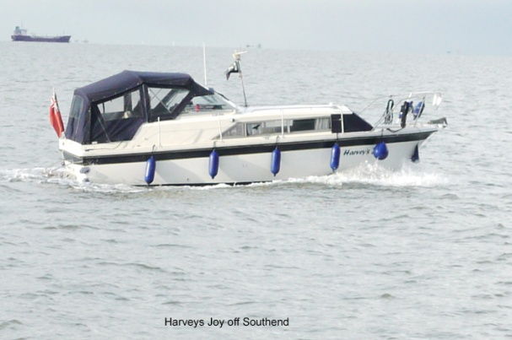
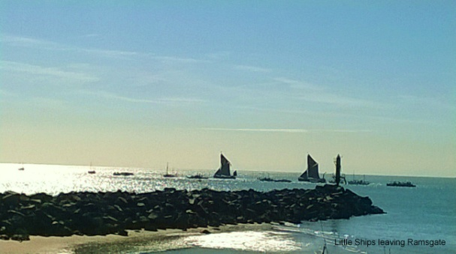
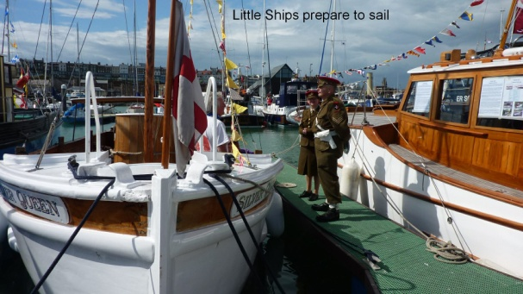
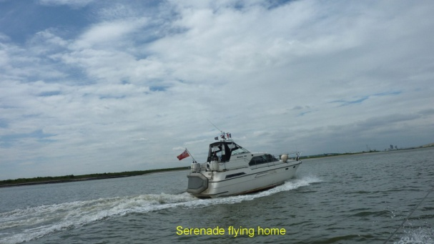


Dates for your diary ...

JULY
Saturday 4th July Summer two week cruise, commencing at Boveney Lock
Sat/Sun 25/26th July Flukey Trophy and Games Evening (re-scheduled)
August
Fri/Sun 28/30th August ATYC Rally

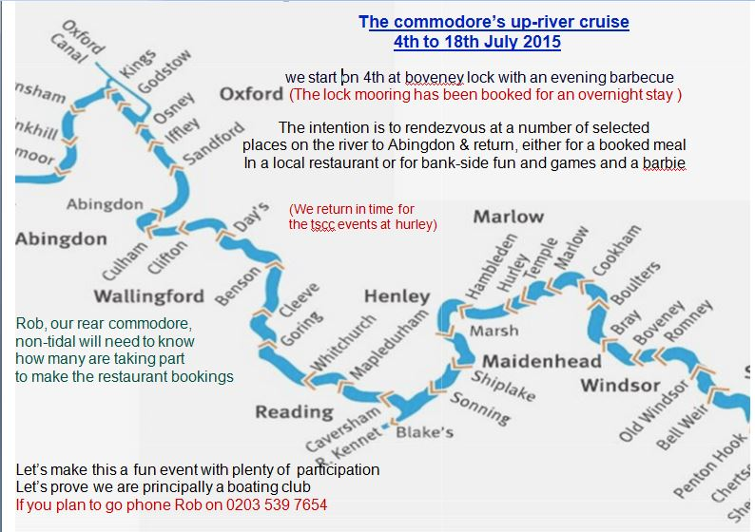
Its not too late, if you'd still like to participate...


The Small Boat Club would like to invite members of Weybridge Mariners Club to join them at their Safari BBQ night on Stevens Ait, where there will be music, a live band, good food and a hog roast!.
Date: Saturday 11th July
Time: 18.30 for 19.00pm
Price: £12.00 adults / £6.00 children under 12
Please dress up and bring your own drinks. Vegetarian option food is available on request.
Note: Water taxi's are available

WMC Mid Summer Ball
This year our Summer Ball was on the eve of the summer solstice, but it really started on Friday when a number of members put up the decorations and arranged and laid the tables ready for the Saturday dinner and dance; Gill choosing a mustard yellow and green colour scheme.
Guests and members started to arrive at seven o-clock and it wasn’t long before the club house resounded to the loud buzz of everyone chatting. Gill, Roy and Mandy had been at the club very early to prepare the meal of melon and Parma ham starter followed by a main course of chicken in a savoury sauce with young potatoes, carrots and peas and concluding with a selection of desert – the hazelnut meringue Rouillard was made by Lesley, and concluded with cheese and biscuits. Jugs of Mandy’s special white sauce were handed to each table for the main course. Jim called everyone to attention at 7.40 to start the meal and asked for each table to select a monitor to go up for the main course; much better than everyone queuing.
During the meal we had background music from CDs played for us by Derek James, who we met last year in the autumn at the A.Y.T.C. rally in London, when he ran a successful disco there in the marquee. After the meal he played his keyboard and sang, getting many on the floor to dance: he even had an interval with us singing some of the old wartime songs. His choice of music was excellent and well suited to our group – the floor was rarely empty. The raffle, arranged by Gill, was held in the interval with some very novel and pretty prizes.
It was a very jolly evening and a great welcome to the summer. A measure of success was the fact that the dance floor was still full for the last dance at 11.30; I do believe it would have continued if Derek had carried on playing.
Jim concluded by thanking Derek for his enthusiasm, Gill and Mandy for the food, Roy and Terry for manning the bar and the members and guests for having a great time.
Jessie English.

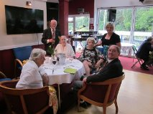
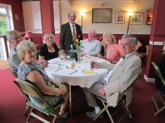
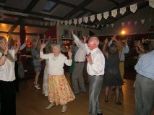
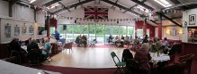


For further details on items that will affect boaters on the river, please click on the following URL link, which contains information sent out in the Environment Agency's "River Thames News Splash" newsletter: https://www.gov.uk/environmental-management/boating?dm_i=B4H,3D6T2,1FZIOO,C1I5Y,1


An appeal from Maggie Barton ...
As some of you know, I am a volunteer crew for barges on the Grand Union; some of you have kindly provided warm/wet clothing for our clients.
The charity which used to manage the boats went bust - don't ask - at the end of 2013 and volunteers and former staff were so committed to the service we provided continuing that they got together and formed another organisation and had the boats back on the water by May 2014. Since then, with no 'staff', they are now getting more bookings than the former paid staff were achieving.
However, we are now victims of our own success, as we don't have enough people to man the boats - the two 12-person wide beams needs x3 and the biggie needs x4 when more than 30 on board, and always a Duty Manager at the base; it comes under marine regulatios, would you believe. We are therefore now having to refuse bookings - no more in June, when potential hirers are not able to be flexible on dates.
Yup, I bet you've got there before me ... we need more volunteers and I think it would be perfect for so many of you, especially those who for various reasons no longer have their own boat; as you know access to canal boats is so much easier than 'tupperwares'.
The base is just outside Kings Langley, J20 off the M25, 30 minutes from Staines - most of the time - and travel costs can be paid. Trips don't start before 10am - crews are asked to be there 30 minutes before - and latest finish is 5pm, though it takes about 30 minutes to tidy up.
Our clients are very varied: elderly - with and without perfect memory, disabled - young and old, mental and physical - but all with a sense of humour. Then there are the parties: birthdays, anniversaries, stags, hens, booze-ups and crew are included for lunch on most of the trips.
Training - walk in the park for Mariners - is given and I'm sure it wouldn't be long before you were skippers; if I can do it .........
I can promise you, you will enjoy it and get a lot of 'job' satisfaction if you decide to do it; could even go as couples. Oh yes, there is no commitment to particular days or how many trips; vacancies are circulated and you volunteer if convenient.
Please think about it; more info at www.wexp.org.uk


This is an urgent appeal for bar staff, as currently during the month of July there are no volunteers! This is owing to many of our regular "staff" being away on the Summer Cruise, which is taking place during 3rd - 19th July.
If you are not going on the cruise, and are able to help man the bar during that time, then please contact Maggie Barton on email:

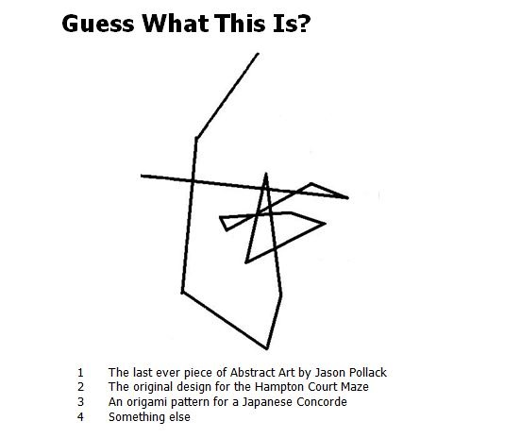
The answer is at the bottom of the newsletter

Joke Corner ...


I would like to take the opportunity through the WMC Newsletter of thanking everyone who sent me ‘Best Wishes’ cards, emails phone calls etc.
I won’t go into the graphic details of what happened needless to say it was not the ‘Down The Hatch’ that I would recommend to anybody. I can also categorically state that it was not designed as an exercise to see just how well the emergency services would cope with getting someone off a boat (so totally the opposite of when I declared a Man Overboard exercise 2 years ago on the River Medway!
The ambulance services were fantastic and at one time there were 5 emergency vehicles on the scene. My thanks also to Jessie and Gordon who were the first on the scene and kept an eye on things (and a camera lens). Likewise I have nothing but admiration for the medical teams in St. Peter’s Hospital. The A+E team, the staff in Swan Ward, the Orthopaedic team and the Orthopaedic Assisted Discharge Team, all of whom performed flawlessly and helped me get back on my feet as quickly as I have done.
I am now using a single stick to get around and my leg feels fine, however the anklebone which has a small fracture on it continues to hurt like *%&$ at times but it is one of those things that they say will heal itself in time.
HOT TIPS
Never leave a hatch open if you aren’t working down there!
Never leave your mobile phone on the top deck when you are working around an open hatch !
Brian Mitchell
PS Dunkirk - Congratulations to Colin & Rob & Bloody good attempt by Roger & Lynne Pothecary and Joy & Harvey Bell. Wish I had of been there


... and finally
Su Knight has had a bad fall, resulting in a broken wrist, fractured ribs and extensive bruising. I am sure we would all like to wish her well.

Answer to Guess What this is?
Well our Commodore thinks that its a plot of Brians route home after a few bevvies, but the actual answer is... we are not at liberty to say, but always remember to switch your AIS off when you go aground!

Copyright © 2015 Weybridge Mariners Club Limited, All rights reserved.
Our mailing address is:
News_at_WMC@outlook.com
unsubscribe from this list update subscription preferences

