View this email in your browser
Use this area to offer a short preview of your email's content.

February 2017 Newsletter



Commodore's Report
Dear Members,
We have started the new year off in a great way. We have a great Committee and lots of new ideas for bringing the fun back into the club. I am sure you will all agree that Valentines dinner dance was a great success and my thanks go out to all the members who worked so hard to give us all a good evening.
The Skittle alley has been ordered and should arrive in the next few weeks, then the games will begin.
Terry has planned a great Easter weekend with plenty of interesting things for us to do
Chris is working out plans for his tidal cruises and will give us details when he has completed his plans
Well done to both of our Rear Commodores.
Finally It was great to see our past Vice Commodore Chrissie Drummie back on board after her illness and we all wish her well
Well that’s all for now folks.
Roy Nash
Commodore
February 2017


Dates for your diary ...

March
Saturday 4th Fitting Out Supper
Sunday 19th St Patrick's Day Lunch
April
Sunday 23rd St George's Day Lunch
Please ensure that should you wish to attend any of the above events, that your names are put down on the noticeboard at the club as soon as possible. Thank you.

With regards to the above forthcoming functions, please don't forget that the club is always looking for members to volunteer and help organise these events. If you don't feel that is something that you can do, you can always offer to help with the decorations, which are usually done on a Friday evening, and help is always required to clear tables, wash up, tablecloths to be laundered.
There are many jobs and so few people ... can you give any time to help?




Weybridge Mariners Fitting Out Supper - £14 per person
Saturday 4th March, 7.00pm for 7.30pm
We will be serving Sausages, mash, beans/peas and onion gravy, followed by
Apple pie and custard, cheese and biscuits
(Vegetarian option will be available, pls request when booking)
Dance the night away to the fabulous sound of Gareth Thomas
This is one of the most popular events of the year, not to be missed!
Please put your names on the list in the clubhouse, or contact:
jan mobile - 07939 553923, or
takeyourmarks - mobile 07941 810227
Please note last bookings taken on 1st March, and cancellation less than two days before, or no show, will have to be paid for.


Weybridge Mariners St Patrick's Day - £18 per person
Sunday 19th March, 1.00pm for 1.30pm
We will be serving Gammon with colcannon, an assortment of vegetables and jus, or Irish stew, followed by a choice of desserts, cheese and biscuits
(Vegetarian option will be available, pls request when booking)
Come along and enjoy the craic with the fabulous Grainne Carter (O'Connor)
singing your favourite Irish songs
There will be a prize for the best Irish joke and even maybe the best Irish jig!
The dress code is something green!
Children aged 5 and under eat for free, children aged 6-10 eat for half price
Please put your names on the list in the clubhouse, or contact:
jan - mobile 07939 553923, or
takeyourmarks - mobile 07941 810227
Please note last bookings taken on 16th March, and cancellation less than two days before, or no show, will have to be paid for.


Valentines Night
Saturday 11th February
The new committee certainly started off the new social season in style. The outside steps were lit with a myriad of tiny white lights and the inside was beautifully decorated with colourful bunting, masses of hearts, strings of coloured lights, flowers on the pillars, candles and red roses on the tables. The decorations took Brian and Doreen 7 hours to do with a bit of help from Roy, Gill, Jan and Mandy, and the clubhouse looked lovely.
We had a delicious 3 course meal cooked by Mandy, Jan and Gill with coffee and chocolates to follow.
Music was provided by Michael St. Claire who got most of us on our feet dancing the night away.
There was a bit of a crisis in the middle of the evening when both sinks in the kitchen got blocked but Terry Hoyle and Jim Hamments soon got things running again. Please note, any food scraps should be rinsed down the left hand sink which has a waste disposal unit. A tap should be running all the time that the disposal unit is switched on.
The only other crisis was when the tea towels ran out but Linda Walpole fetched some from their boat. If anyone has any of the club tea towels at home being washed would they please return them as soon as possible.
It really was a great night out and it was lovely to have the club house full. 62 people came and it really made things swing.
All those involved in the organisation are to be congratulated. If this is a foretaste of socials to come we are in for a good year.
Lesley Hamments



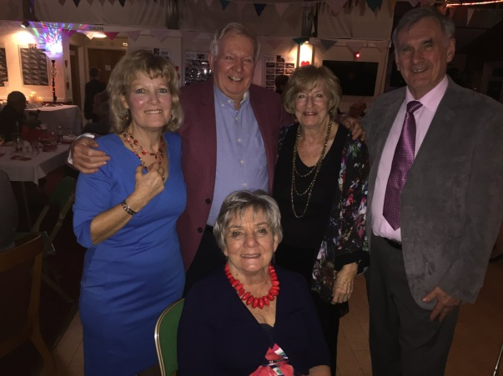
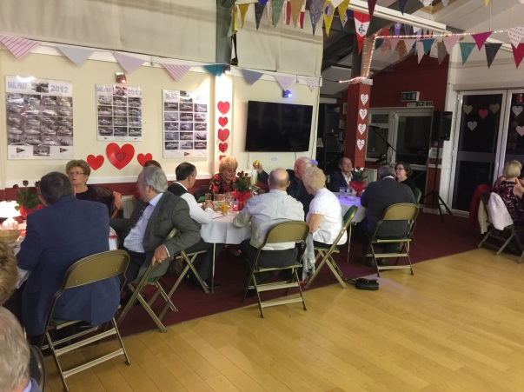

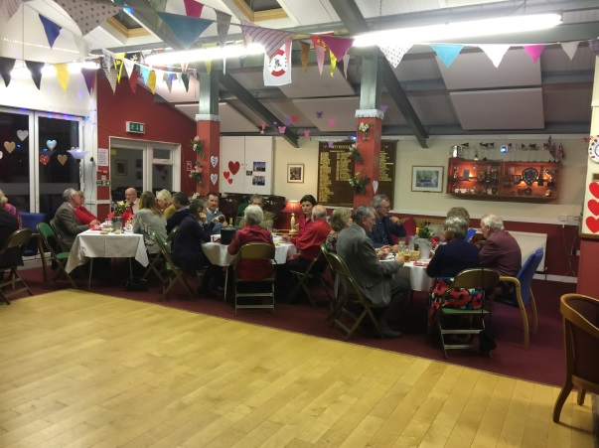



Time & Tide boats are organising a Traditional and Classic Boat Auction at Beale park this summer, which is taking place between 2nd and 3rd June 2017.
They are looking to sell a large variety of wooden and collectable boats at the show including; sailing dinghy and open day boats, rowing and powered.
If any members have such boats that they are interested in selling, then please contact Peter at Time and Tide boats via their website www.timeandtideboats.com
or email Peter directly at peter@timeandtideboats.com
Please be aware that if you have a boat to sell, and also wish to attend the auction, then you can register for a special discounted bidders package, details are on their website.

Joke Corner ...

Copyright © 2016 Weybridge Mariners Club Limited, All rights reserved.
Our mailing address is:
News_at_WMC@outlook.com

