August 2015 Newsletter



Commodores Report
Since the last issue there has been the quiz organised by the RNLI, which, by all accounts, went well. We have also had a very successful Cream Tea event (see David Perry’s report). This event was planned entirely by Heather and Doreen; aided by Annette and Maureen. What a great afternoon it was: sun shining, balcony doors wide open and excellent food, with almost fifty in attendance. Heather asked for proceeds from the event to be put towards the Children’s Christmas Party, to which I willingly agreed.
Well, the ATYC Rally was cancelled because only one club forwarded entries – THAT WAS US. The WMC was the only club to respond and I was proud that at least we showed we were keen to support the ATYC.
Planning for the Dunkirk Vets visit (6th September) has been completed and the WMC teams have now been allocated and notified: my thanks to all the volunteers. Unfortunately, because we will have a very full house (over 100 seated guests) I would ask that only those taking part come to the club that day, and thank you all for your cooperation in this. We have been told that around 20 Little Ships will be in attendance, including the MTB Flagship of the ADLS.
I had hoped that we would have the landline installed by now but there has been some confusion over which poles to use (telegraph not E.European). Deirdre is on the case.
Those who come to the club will have noticed that the access ramps to the pontoons have now been reversed; hinged on the landward side and rolling on the pontoon with the rise and fall of the river. The ramp angle has gone from a steep and awkward 45 deg at current river level to a more benign 20 deg, ideal and much safer for the Dunkirk Vets visit. This modification is thanks to Jim Hamments and his team of workers. All that is needed to finish the job is for the hand rails to be extended to the bank-side and this work is in hand. With the ramps arranged as they now are, they can be raised clear of the pontoons in times of flood; lowered should access be necessary.
As reported last month the cooker has been serviced but there was a complaint that it could not be lit. If the instructions are followed and the extractor fan is switched on before attempting to fire it up, it will light. While on the kitchen, please see the Vice Commodore’s report below.
Don’t forget the photographic competition at the Commodore’s Sail past (Saturday 19th September). The theme is anything to do with the club and taken at any time (it can be of the building, an event, a cruise, a member or members, use your imagination but no “photo shopping” - except to improve brightness or contrast).
Rob has arranged the Flukey (26th September) and will need some help: he will need 2 WMC Judges; he now has the club competitors. Let’s hope that we get plenty of members spectating, to cheer the competitors on.
I still have no solution to the parking problem. I asked Nauticalia if it was possible to use their car park but they have turned us down due to the need for security on their premises. I am still awaiting a response from the island syndicate that now own the far car park.
I didn’t get any response to my desperate request in the last newsletter for help on the committee. Is there no one out there willing to put their name forward? If you should be thinking of it but are uncertain as to the commitment why not talk it over with me: your club needs you!
Jim Pothecary.
Brief Report from the Vice Commodore
Lesley has done a thorough job going through all the cupboards in the kitchen checking dates on food. This was a very important task as we are imminently due a health inspection by Spelthorne council.
Lesley has asked that unless there is a known, soon impending use for any food left after an event, then it must be removed at the end of the event. If we were to be subject to a snap inspection, and this does happen, we would be in difficulties if this is not done. Please bear this in mind if you are organising an event.

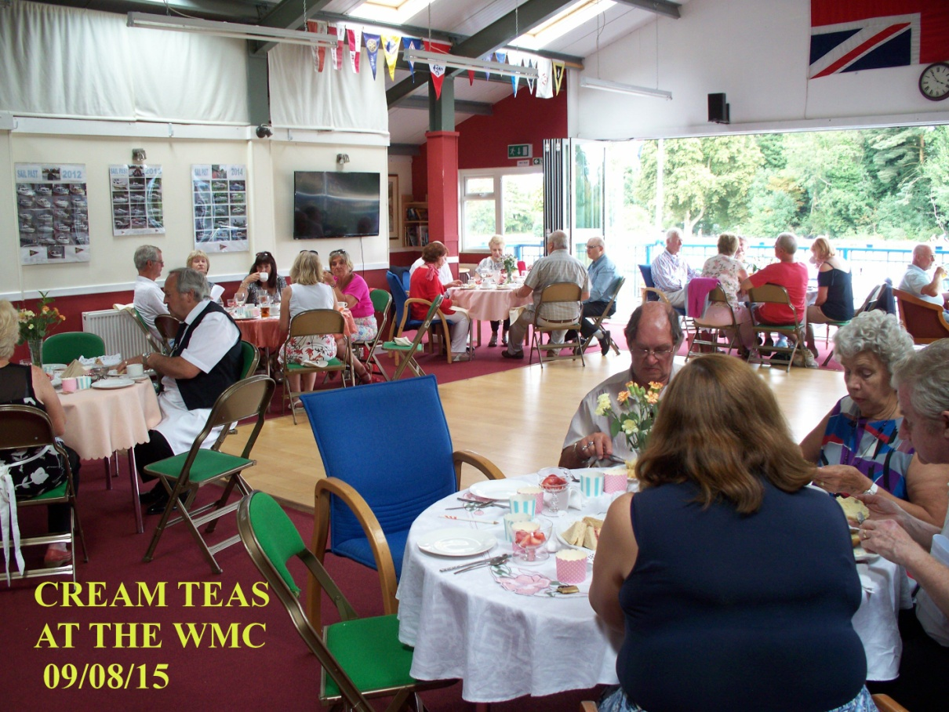
Afternoon Tea at the Mariners
The afternoon Cream Tea event at the Weybridge Mariners Club held on Sunday 9th August was very well attended. The setting was a lovely sunny summer afternoon on the river with the bi fold doors fully drawn back for members and guests to sit out on the veranda in the sunshine just to natter; with many old and new members and guests catching up on news, or to just admire the view across the river and watch all the river activity: boating, canoeing and sailing and families out walking in the fresh air on the opposite bank.
There were nearly 50 at the event for that afternoon session and all eagerly anticipating the spread: being seated at 3.30pm and still going strong after 6pm, It was all credit to the hard work putting together the tea of scones, cream, jam and strawberries, a large selection of sandwiches delicately trimmed of all crusts and followed by cakes including lemon drizzle, sponges and chocolate cake; served with tea and coffee of course, which was much appreciated. The bar was open for the whole afternoon for those requiring something stronger to avoid over-heating and dehydration on that hot summer’s day.
The catering was carried out by, Heather and Doreen, who started preparation very early in the morning, and with Maureen and Annette working hard alongside; all to a very high standard of course. It went especially well considering a lot of the items had frozen in the fridge and had to be thawed out in time for the event Heather was very concerned that the strawberries would not be up to standard but she need not have been concerned as they all went down a treat. Everyone was given a raffle ticket as they paid, which was drawn after the tea and, to his utter amazement, was won by the Commodore. All this was set against light back-ground music, which enabled conversations to be carried out in a normal fashion.
Thanks must go to Heather, Doreen, Maureen and Annette: to Frank, Peter and René (a.k.a. Brian T), behind the bar and to all those that pitched in to do the washing up and clearing away. Heather asked that any money made on the event be put towards the Children’s Christmas Party. This lovely suggestion had the full support of the Commodore.
All in all a very successful afternoon, which ran like clockwork and was enjoyed by all. The Mariners continues to grow from strength to strength, as proven by the number attending on that exceptional summer afternoon.
Once again a good afternoon and we are all looking forward to the next one.
David Perry


Dates for your diary ...

September
Sunday 6th September Dunkirk Veterans Visit
Sunday 20th September Commodore's Sail Past
Saturday 26th September Flukey Competition and Evening Social
October
Saturday 3rd October Ladies Night
Saturday 17th October Laying Up Supper
Saturday 31st October Casino Night


You are invited to ...
Weybridge Mariner's oldest member, Gladys, will be 101 years old on the
29th September! To celebrate this amazing milestone, Gladys, and her son, Phil Boys, will be hosting a party on Sunday 11th October, at lunchtime, starting at about 12.30pm.
Gladys would love for lots of Mariners to attend, and there will be a buffet lunch served at approx 13.00pm, which will be provided by Derek Dale, just like the good old days!
The amazing magician that was booked last year has been booked again, and will start performing tricks at approx 14.00pm.
Although its Gladys' birthday, purely by accident the nearest day to her birthday that the club was free also turns out to be Phil's 70th birthday, so it will be a double celebration, celebrating 171 birthdays together!
For those WMC members that would like to attend, and celebrate with both Gladys and Phil, please RSVP to Phil by email for catering purposes.


Thanks to Rob Fry, who organised and fitted the safety rails to the modified pontoon ramps in plenty of time for the Dunkirk day - such a shame he will be on holiday then and will not see the veterans making use of the improved facilities!


For all you shoppers out there, Martin Trevor, Shop Manager at Nauticalia, has promised a 10% discount to any WMC member that purchases in the shop, upon production of your WMC membership card.


Another one for the sick list ...
Some of you may know that Billy went to America last month to do some clay pigeon shooting: I chose not to go as it was in the "boondocks" (American friend word), very hot and no outdoor pools as would freeze in the winter when it's very cold, therefore not even gardens as too hot to sit in!
Not surprisingly, several jobs needed doing when he got home; grass to cut, landing stage to clear of debris which I'd gathered up, patios to sweep etc etc.
He cut the grass the day after he got home but next day was his regular weekly shooting day - Yes, I know! - but no problem as still plenty time to get it done before he was due to go to Holland - shooting, of course - as that was a week away.
Came home that evening to tell me he'd had an accident, tripped on a tree stump and hurt his chest but nothing a couple of Paracetamol wouldn't sort out.
I can't say what happened next was because he didn't want to have to do the aforesaid jobs but it did stop him!
Following day, Friday, Gill came to take her boat away to do some work on it - easier at Penton Hook 'cos Roy's there - and they found that a large branch had broken off the willow tree.
It was large as took both Billy and Roy to move it. Billy therefore decided that, while the boat was gone and Roy would be back to help move them, he'd cut some more branches which looked in danger of breaking off. In fairness, he couldn't have wanted to have an accident as decided to tie the ladder to the tree - not something he'd usually do but would be using a chain saw ......
Thing is, having tied it to the tree, he must have been a tad blasé when descending to get the chain saw and, before he could say "******* Rod Hull!" the ladder had spun over and sent him onto the landing stage, by way of the brick wall. Not sure how long he lay there thinking he must have damaged something - apart from the wall - but first I knew of it was when he crawled into the house to tell me he'd - you got it - "had an accident". Now I'm no Florence Nightingale but, if I say so myself - oh yes, wouldn't go to hospital - I did a pretty good job of cleaning and bandaging the worst of the wounds and strapping his ankle - the one that's already scarred from childhood accident. Couldn't do much about the grazing on his arms, chest, back and legs but our neighbour who came in came back with an "old Indian remedy" which would stop the pain; it did, 'cos it stung so much he couldn't feel it anymore!
Fortunately, as I've told people who've asked how he is, "He's a lot better than he deserves to be" and cuts, grazing and ankle are on the mend. Only problem is his chest is still hurting from the first accident so, on Wednesday, he finally agreed to go to Ashford Walk-In Centre. Even if you've by now lost the will to live, you must please keep reading as you have to know what excellent treatment he received.
We left home at about 1 o'clock and were back by 3.00, having seen a doctor at Ashford, been given a letter to have an x-ray, gone to A&E at St Peter's, seen a doctor, had the x-ray and been told nothing broken, damaged or out of place; discomfort when breathing/turning being caused by the knife I'd stuck in his back! No, not really, it's due to internal bruising and only time will get it better.
In fairness, he has done some little jobs today - Holland had to be cancelled - but there's still a lot to be done once he's better ............
Moral of the story of course is not to go climbing trees anymore and we've got someone coming on Monday to look at ours.
Maggie Barton
Vic Lundberg Update
Vic Lundberg has completed his principle treatment and is progressing well. Because he has made such good progress he is now on a special medication that specifically targets the remainder of the cancer. He and Joyce wish to be remembered to the members, and hope to visit the club soon if all goes well.
Graham and Frances Hearnden Update
As you may know, Graham & Frances Hearnden have been thorough the wars. Frances had broken her ankle and Graham had an injured back. Both are progressing slowly. Frances has had her plaster removed but Graham reported that she is still in pain; so much so that an early visit to the club is out of the question. Meanwhile, Graham is having to be pulled about by a chiropractor to repair the damage to his back. We send our good wishes for a speedy recovery and look forward to seeing them as soon as they are able to get to the club.

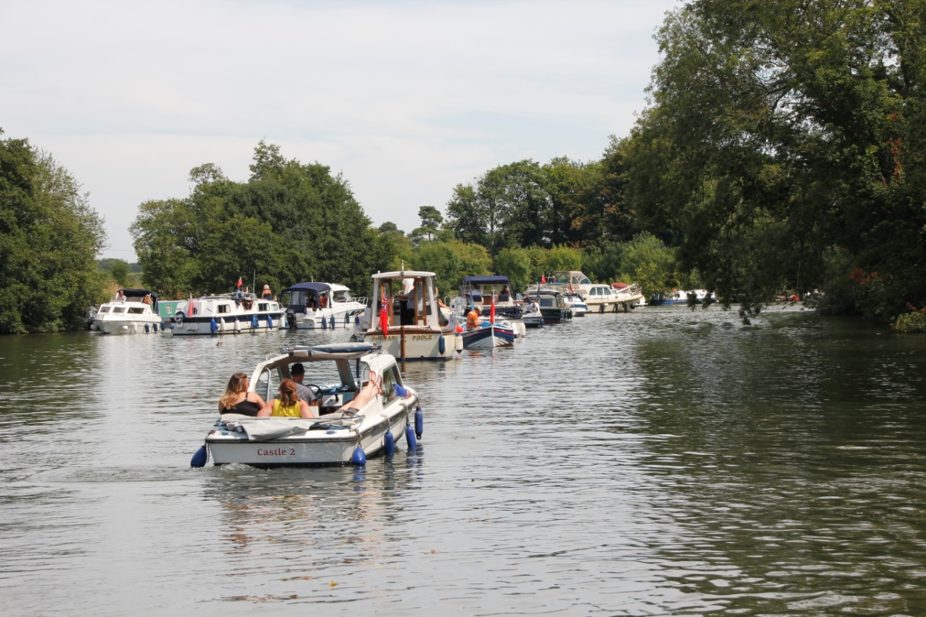
and finally ...
Some of you may have heard about the boat explosion that occurred by Bray Lock on Sunday 2nd August, picture above is the queue of boats above Bray Lock at 5.00pm on the Sunday of the explosion. (Photo courtesy of Roger Pothecary)
Six people, including a three-year-old boy, were taken to hospital. Friends and family were on board the privately owned vessel when at approx 12.40pm a loud bang was heard, and reports suggest that fuel, poured into the wrong pipe was sparked by the boat's battery, which ignited causing an explosion.
Fortunately, none of the injuries are thought to be life-threatening.
The WMC Editor and husband (Roger) happened upon the scene minutes after the explosion occurred, and went through Bray Lock which subsequently shut after them, causing Roger to have to spend the night moored at Maidenhead, returning to their marina the following morning.
Whilst Roger was moored at Maidenhead, the Fire Brigade visited boats and handed out the attached useful leaflet regarding fire safety on boats, which I thought it would be helpful to circulate to all members, and to remind members of the following pointers for boat safety.
Below is a picture of the said boat, again courtesy of Roger Pothecary, currently on hard standing at Bray Marina.
Be safe out there!
The Editor

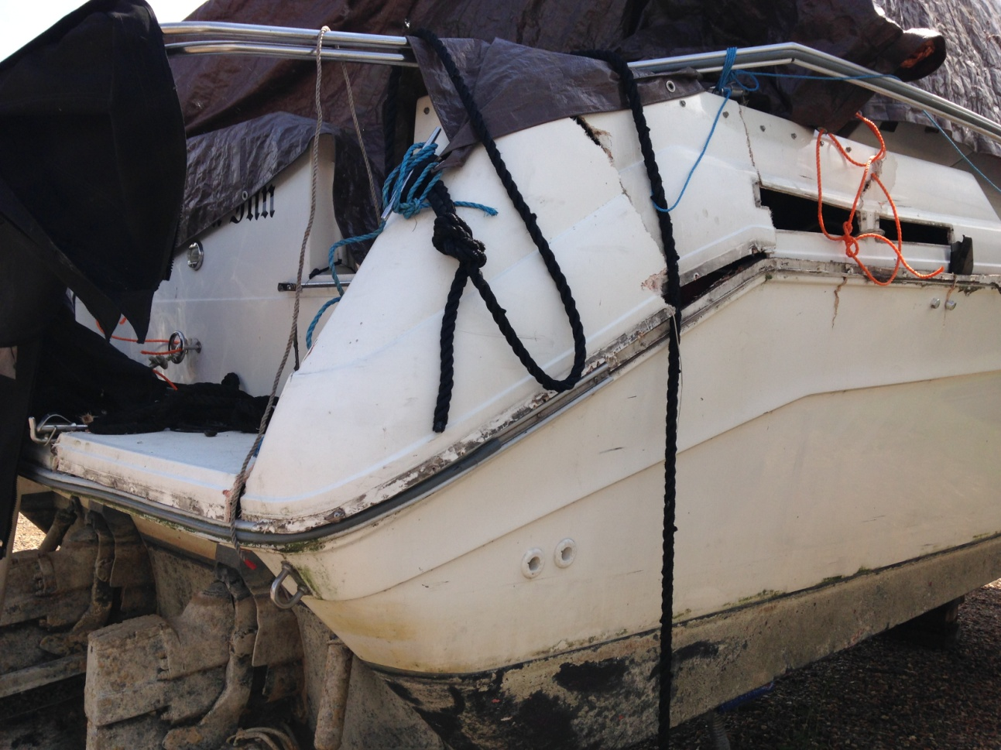

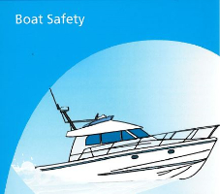
Boat Safety (Courtesy of Royal Berkshire Fire and Rescue Service)
Refuel safely
- Stop the engine
- Make sure all named flames are out
- Don't leave anyone on the boat
- Close door and raise awnings to prevent petrol vapour gathering in cabins and cockpits
- Avoid spillage
- Never decant petrol on board, in a lock or next to other craft
- Re-fuel outboard tanks ashore and well away from the boat
Gas Safety
If you smell gas ...
- Turn off the isolation valve, open windows, hatches and doors
- Turn the engine off
- Put all naked flames out including pilot lights
- Don't switch any electrical goods or mobile phones on or off
- Evacuate the boat if possible
Good Practice
- All equipment should be serviced regularly and kept well maintained
- Switch off appliances when not in sure
- Keep ventilators open and unobstructed
- Use the bilge blower before you start a petrol-engined boat
- Make sure solid fuel burners are well ventilated
- Know where fire extinguishers are located
- Know how to operate the extinguishers
If there is a fire
Alert everyone on board. Evacuate to safety
Use extinguishers to help you escape
If the fire is in the engine space don't open the main access
If you can use an extinguishers safely, do so
In case of fire call 999
website: www.rbfrs.co.uk
email: community.safety@rbfrs.co.uk
Helpline: 0118 932 2152

Copyright © 2015 Weybridge Mariners Club Limited, All rights reserved.
Our mailing address is:
News_at_WMC@outlook.com
unsubscribe from this list update subscription preferences

